**MODEL PREDICTIVE CONTROL VERSUS TRADITIONAL RELAY CONTROL IN A SMART GREENHOUSE**

Chiara Bersani1, Marco Fossa2, Antonella Priarone2, Roberto Sacile1, Enrico Zero1

1DIBRIS – Dept. on Informatics, Bioengineering, Robotics and Systems Engineering, University of Genoa, Italy

2DIME – Dept. of Mechanical Energy, Management and Transportation Engineering, University of Genoa, Italy

**Summary**

The sustainable agriculture cultivation in greenhouse is constantly evolving due to the new technologies and methodologies implemented to improve crop yields and to solve the common concerns which occur in protected environments.

This paper presents the development of a MPC-based greenhouse microclimatic environment control system to optimize the indoor air temperature of the greenhouse according to the requirements of the specific crop cultivation. The aim of this work was to determine the optimal control signals associated to the water mass flow rate supplied by the heating pump applying an effective MPC model which allows the greenhouse system to track a predefined temperature profile with an energy saving approach.

The MPC has been implemented as a multiobjective optimization model which takes into account the dynamic behaviour within the greenhouse by energy and mass balances. The energy contribution is provided by the heating system, realized by ground coupled heat pumps (GCHPs), and by the solar radiation while the energy losses are due to the heat losses through the glazed envelope and the heat transfer between air and the internal masses of the greenhouse. The proposed MPC method has been tested in the smart innovative greenhouse located in Italy. Results demonstrated that the application of the proposed model generated better performances in comparison with a traditional reactive control.

Due to the significant climate changes occurred in the last decades, the introduction of new methodologies and technologies has become essential to support agriculture and to optimize greenhouse productions.

In the last 20 years, in the Mediterranean climate area, vegetables and fruit cultivation has become more and more competitive. According to Eurostat statistics [1], EU farms used 173 million hectares of land for agricultural production in 2016, 39 % of the total land area of the EU. Agriculture contributed 1.2 % to the EU's GDP in 2017 [2].

In this context, the adoption of modern technologies, which consist of different sensors for ICT based crop health monitoring, is essential to improve the quality and the efficiency of production, and to implement smart crop automation systems [3]. The introduction of greenhouse smart agriculture using automation and control technologies may favour the crop growth, allow energy and water saving, and reduce disease infection and pesticide adoptions.

Smart agriculture applied to greenhouses is also a very interesting technological sector from the energy viewpoint. In fact, the increasing demand of product quality and vegetable production availability all-year-round imposes to the producer to equip the greenhouses with suitable heating and cooling plants to regulate temperature, humidity, and luminosity, driving a healthy and controlled production. In this framework, it is mandatory to select proper high efficiency technical solutions to reduce the energy consumption and, as a consequent, the production costs. A critical point is the economic sustainability of this type of production, especially in the global market: even excellent quality products are not competitive when their price is too high.

Therefore, the greenhouse agriculture is more and more investing in technologies, passing from traditional to ICT controlled production resulting in a “smart”, greenhouse environment.

This paper is related to two innovative research projects developed in one regional project, later exploited in an international context. The “Smart Agro-Manufacturing Laboratory (SAM-LAB)” project has been developed in 2014-2016 in the framework of a Regional Italian Programme, namely funded by Liguria Region PAR FAS programme. The final goal of the SAM LAB project was to define strategies enhancing the greenhouse facility management in the direction of improving the cultivation systems and reducing the overall required energy. Based on this experience, the Interreg ALCOTRA project between ‘Italy – France’ has more recently funded the Antea project “Edible Flowers: Innovations for the Development of a Cross-Border Sector” (2016-2020). The project aim is to support innovation to promote the nutritional characteristics of edible flowers and broaden the range of varieties, setting up an innovative production, commercialisation and consumption system for the product. The link between the two projects is the realization and operation monitoring of an innovative prototype greenhouse at Cersaa (Center for Agricultural Experimentation and Assistance) in Albenga, Italy (Figure 1). The greenhouse is equipped with new materials for the glazed shell, innovative plants associated to renewable energies and suitable advanced ICT monitoring and control systems. The research focuses on the definition of solutions for energy efficiency improvement in greenhouse agriculture and on the dissemination of results.

Such greenhouse has been tested for several experiences from the technological and methodological viewpoint. Among such experiences, heating the greenhouse tracking a specific temperature profile may represent a perfect example where Model Predictive Control (MPC) can give better performance when compared to traditional relay controls. In this paper, after a survey of current challenges in greenhouse production, a MPC approach is presented and compared with a traditional control solutions. The MPC has been implemented as a multiobjective optimization model to find the optimal control signals associated to the hot water flow in the heating plant.

In recent years, new technologies, methodologies and best practices enhanced the efficiency and sustainability of greenhouse cultivation. The adoption of technical solutions such as the shading of glazing surfaces, LED lighting, the remote control of ventilation, heating, cooling and thermo-hygrometric systems addressed successfully the improving of the indoor greenhouse microclimate by an energy-saving approach.

**Smart greenhouses applications**

Recently, new alternative cultivation techniques and greenhouse systems have been developed to support crop production in the perspective of unfavourable environmental conditions especially in areas where conventional farming systems are difficult to be applied.

The Nemo's Garden project (2012-2020), for example, has developed an underwater farm which consists of six biospheres made by acrylic material completely immersed in the sea, at 5 to 12 meters depth, at 100 meters from the shoreline, close to Savona, in Liguria Region, Italy [4] (Figure 2). This application focused on the creation of a self-sustainable farming system based on fresh water production, comfortable stable temperature and isolation of the greenhouse environment from external contamination and external air weather condition. The water cycle inside the underwater greenhouse depends on different parameters as the vapour partial pressure and the temperature inside the air volume, the radiation and the surface temperatures, the sea temperature, the vapour removal by specific heat exchangers and the plant watering system.

In [5], the authors described the design of a greenhouse module for the lunar space system (Figure 3). In fact, the project aimed at developing a closed-loop bio-regenerative life support system, required for future long-duration human space flight with the realization of the lunar greenhouse system able to produce specific quantities of selected plants so to satisfy the dietary requirements for a crew of six persons.

In arid areas or in countries with limited rainfall, the development of seawater desalination plant based on renewable energy system (RES) is becoming a significant added value for the protected agriculture. An interesting example are desalination units based on renewable hybrid system using sunlight and seawater, that are able to humidify the air of the greenhouse and to produce fresh water [6].

In a confined environment as the greenhouse, the requirement of controlled internal conditions for long time operation determines an increasing energy consumption which represents a problem not only from the environmental point of view but also from the economic one.

One of the main expensive task in greenhouse management is the energy cost associated to heating and cooling plants [1]. In [7], the authors propose a review and a performance evaluation of innovative and renewable heating technologies for greenhouse applications. They presented a deeper analysis of several energy saving solutions as thermal storage, ground-to-air heat exchanger systems, movable insulation/thermal screens, optimal use of the north wall, ground air collectors, and aquifer coupled cavity flow heat exchanger systems.

Moreover, in [8], the researchers proposed a comprehensive description of cooling techniques for greenhouses, including renewable technologies as the roof evaporative cooling, the ground-to-air heat exchanger system and the aquifer coupled cavity flow heat exchanger system.

In [9], the authors analysed statistical performance of a microclimatic model for a naturally ventilated greenhouse for cucumber crop by considering the heat and mass transport processes. In [10], the authors evaluated the energy demand of the greenhouse through an hourly numerical simulation, using the Energy Plus (E-plus) software.

In order to minimize the energy produced by fossil fuel, the introduction of devices based on renewable sources as geothermal heat pumps represents the first step to decrease harmful emissions [11]. Heating/cooling systems affect significantly the grow, the quality, and the cultivation time in the greenhouses [12]. In particular, the indoor environmental parameters in the greenhouse must be monitored and controlled to support crop growth [13].

Greenhouse heating is important even in countries with mild climate, like the Mediterranean region, in order to maximize crop production. Heating costs not only have a critical influence on the profitability but, in the longterm, may also determine the survival of the greenhouse industry. In Italy, the cost of heating currently accounts for approximately 30% on the cost of production in the greenhouse. Moreover, high-energy consumption heating systems are associated with environmental problems through the emission of noxious gases.

The geothermal (ground-source or water-source) heat pumps represent one of the most important green energy solutions to realize a heating or cooling system for domestic and industry applications [14]. The ground coupled heat pumps (GCHPs) work extracting injecting heat from/to the ground in order to heating or cooling the indoor environment. This technology takes advantages by the fact that the ground, from some 10 meters down on, maintains an almost constant and warm temperature during the year.

Several studies focus on the implementation of RES based integrated systems for energy production and storage technologies, describing technologies and optimal energy management of greenhouses [15][16]. According to the above-cited literature, it is clear that the current trend to realize smart greenhouses at zero net energy is becoming one of the viable technological solution to support sustainable food production and alternative strategies at fossil fuel energy production. In this innovative context, in the following section, the description of a real application of smart greenhouse realized in Italy is introduced.

**Technologies for an innovative smart greenhouse in Italy.**

This paper focuses on the performance of an innovative greenhouse realized in Albenga, Italy (latitude: 44.3 DD, longitude: 8.47 DD, altitude: 3 m, time fuse: +1 CET). The greenhouse envelop consists in a rectangular aluminum frame with pitched roof. The base dimensions are 15.3 and 9.9 meters while the eave height is 3.50 m with a roof top of 5.60 m heigh. The material selected for the greenhouse glazed walls is the low emissivity K-glass type N with a thickness of 4 mm, overall heat transfer coefficient 3.3 W/m2K, normal emissivity equal to 0.05 and a solar gain (g-value) of 71% (Figure 4).

The greenhouse is equipped with innovative solutions for the energy consumption reduction and the maximization of the productivity of the selected crop. The air conditioning system of the greenhouse establish suitable profiles or specific set-point for the different control variable in the greenhouse (temperature, humidity, irradiance level, photosynthetically active radiation PAR…). For this reason, this complex system includes different equipment.

To control internal temperatures, one of the simpler and cheap method is to introduce a shading system applied to the glazing surfaces, to reduce during summer the heating contribution due to solar gains. Another passive technique to reduce internal temperatures is natural ventilation by controlled opening windows, located at the bottom of the lateral walls and at the roof top, with a total area of about 30 m2. If the air volumetric flow rate obtained by natural ventilation (wind and stack effects) is not sufficient, an extractor fan is activated at the roof top. Finally, during peak conditions, it would be necessary to control internal temperature and humidity levels by means of an air handling unit (AHU) for both heating and cooling design. The AHU is associated with a Ground Coupled Heat Pump (GCHP).

The energy performance reached by a GCHP can be very satisfactory. In fact, the ground represents a heat source with a stable in time undisturbed temperature that is nearly equal to average air temperature at the considered site. In Albenga, this temperature is constantly close to 16°C (60.8 °F). This value is more favorable for the source side of a GCHP than the air temperature, both during heating and cooling season. Moreover, in the greenhouse applications the GCHP performance is further enhanced due to the target temperatures to be pursued at the GCHP load side. In fact, the internal greenhouse temperatures might be maintained at 18°C and 30°C during winter and summer, respectively.

In particular, fthe ground field is composed by 6 Borehole Heat Exchangers (BHE) double-U pipe of PE110-RT SD11 (HakaGerodur) each 100m long, located around the greenhouse. The GCHP is a water-to-water HP fed on the source side by a mixture of water and propylene glycol coming from a borehole heat exchangers (BHEs) field. The selected HP, an Ecoforest brand, model Ecogeo B3, has nominal heating capacity at partial load factor PLF = 95% of 28 kW for $T_{in}$ = 10°C and $T_{out}$ = 55°C with a COP = 3.7 and a nominal cooling capacity at PLF = 100% of 34.4 kW for $T_{in}$ = 20°C and $T_{out}$ = 7°C with a EER (energy efficiency ratio) = 5.29 (Figure 5). At the load side, the HP provides water to a storage tank (ST). The storage tank feeds in turn the coils of the AHU and also the local heater of the benches placed inside the greenhouse for crop purpose. The AHU is an AERMEC brand, series TN 2 with a nominal air volumetric flow rate equal to 4100 m3/h in cooling mode and 4700 m3/h in heating mode. The estimated overall heat transfer coefficient of the AHU is HTC =760 W/K. The air distribution network is composed by 3 textile ducts AIRMIXING Evoair (Figure 6).

The water tank is thermally stratified, due to the different densities of water related to its temperatures: the hot water coming from the GCHP enters the tank form the top while the cooler coming back from the air heat exchanger settles in the tank bottom section. The ST capacity of storing heat while maintaining the highest level of energy depends on the real temperature stratification conditions that depend on many factors, including the tank size, height and diameter, flow rate for loading and unloading water, water velocities at inlet sections [17]. Reference [18] investigated thermal stratification in hot water tanks.

The greenhouse is equipped with a monitoring and control system based on four subsystems with peculiar features. The hardware system, built as a sensor network, has the task to measure and track each parameter of the greenhouse, and to send the data to a Control Unit (CU). The software system acquires data from the CU, collect and display data, verify parameters of the greenhouse environment. The control system will communicate to different actuators of the greenhouse structure according to the observed parameters in order to set the optimal condition required to cope with the design set points. Finally, a website has been implemented, devoted to the real time visualization of the greenhouse parameters and to generate downloadable reports of historical measured records.

**Sensor network.**

The hardware system is based on an embedded CU, version A20-OLinuXino-MICRO-4GB, a local network of analogical and digital sensors which can monitor in real time each parameter of the greenhouse and an integrated low energy communication module. In this configuration, the control system is equipped with GPRS technology (Figure 7). The devices installed in the greenhouse can monitor the following parameters:

- external weather conditions (temperature, humidity, wind speed and direction);

- air temperature, pressure and humidity at different heights inside the greenhouse;

- light & photon flux inside the greenhouse;

- soil humidity and temperature;

- photovoltaic energy production;

- geothermal heat pump performance;

- heat extracted/injected from/ into ground by the BHE system.

The digital thermometer provides 9-bit to 12-bit Celsius temperature measurements and has an alarm function with user-programmable upper and lower trigger points. Its operating temperature range is from -55°C to +125°C, with a ±0.5°C accuracy in the range from -10°C to +85°C. The digital barometric pressure sensor employs a conditioning IC to provide accurate pressure measurements from 50 to 115 kPa. The lux meter is able to measure the illuminance of natural or artificial light sources, with a measuring cell that returns an electrical output signal (0-10V or 4-20mA) proportional to the light intensity. Moreover, in order to track and set a convenient water irrigation schedule, a water flow meter will be installed in the irrigation system.

All the sensors have been individually calibrated and tested. The sensor network transmission system is based on over a single-wire bus that requires only one data line (and ground) for communication with a central microprocessor.

**Software system and website module**

The CU performs activities related to measurement collection, partial data processing and message packing on multiple queues. The CU acquires different kind of data from the network sensors and it transmits them to the control center server according to different methods. All data are typically acquired at predefined fixed time intervals (e.g. 5 minutes). The data transmission rate can be changed between two predefined modes, by fixed sample time or by on-event request. According to the first mode, the data are periodically sent with the information about the greenhouse parameters while according to the second mode the measurements are sent, for example, in case of detected anomalies or whenever the received values overcome the threshold defined by the control system. It is possible to define an unlimited number of notifications by means of one, or several communication protocols (i.e. email, SMS messaging, website alert message).

**Control System**

The data acquired by the CU are periodically sent by GPRS connection to the Control Center and forwarded to a dedicated internet server. If any parameter of the network system does not satisfy the optimal predefined conditions, an alert message is generated. At the same time, the CU sets the corresponding actuators of the greenhouse in order to modify their status. Specifically, the CU can operate on the following structural elements of the greenhouse: opening/closure of shading system; opening/closure of the lateral side and roof windows; opening/closure of heating and cooling system; opening/closure of irrigation system; opening/closure of lighting system. The classic approach to control in automatic these systems is usually based on relay strategies (e.g. for temperature, switching on the HP when the temperature is below a specific value) or on periodic automations (e.g. for irrigation, switching it on at fixed flows at a specific hour of the day).

**Heat pump energy monitoring**

An additional monitoring system is dedicated to record the operating parameters of the GCHP. The system is based on a Linux micropc platform that controls an acquisition unit able to collect at sampling rates higher than 1 Hz a series of analogical and digital inputs. The measured quantities include evaporator and condenser side temperatures, carrier fluid temperatures from the different borehole heat exchangers, mass flow rate in the ground loop, electrical power at the heat pump compressor and circulation pump. The aim of these measurements is to track the heat pump energy performance in real time and to build a database of working parameters.

**Overview in MPC method for greenhouse efficiency.**

The main challenge in greenhouse management is the microclimate control during the different seasons, to fit optimal crop growing conditions. In particular, the temperature control is essential to create the best values for the overall parameters inside the greenhouse environment to avoid plant stress and to improve efficiency of the crop production. Several research studies tacked the problem and provided different control methods and models for the control of the temperature inside the greenhouse.

The quality of control strategies depends on the availability of information about the variability of the parameters which may affect the actuators choice and the control signals. Usually, the control strategies are mainly based on traditional reactive methods or on predictive models.

The traditional reactive control strategies do not take into account forecast of state and environmental exogenous variables [19]. On the other hand, these approaches based either on on/off relay methods or on proportional, integral, and derivative (P, PI or PID) controllers have a widespread use due to their simple architecture and easy implementation [20].

The adoption of significant low-cost monitoring instruments to control the indoor microclimate greenhouse system aims at providing operators all over the world with useful tools to bridge the theory-practice gap, accelerating the implementation of high-performance advanced control system on the protected cultivation systems and, ultimately, facilitating the access to a cutting-edge research.

Due to the complex mass and heat transfer processes in the greenhouse environment, the implementation of an on/off controller produces, in this kind of application, significative fluctuation of the variables from their input set point [21]. In [22], a PID and fuzzy logic controllers have been implemented to optimize the energy consumption and water use while in [23], the authors proposed a PID tuning scheme for greenhouse climate control by evolutionary algorithm. Therefore, in some applications, the PID controller can generate promising results but, when the operating conditions differ largely from the optimal ones, a controller’ calibration process has to be included decreasing the control performances [24]. Besides, PID control does not usually represent a suitable solution in case of advanced applications, where dynamic controls are essential [25].

On the other hand, Model Predictive Control (MPC) methods received considerable interest in research studies, with applications to different economic and industrial sectors thanks to their robustness and ability to model disturbances and nonlinear constraints [20].

MPC is an advanced control technique, which adopts a process model to forecast the future variables behavior. This approach allows to model complex systems and processes that require receiving control signals in short term by an optimal automated model predictive controller.

Specific literature is devoted to MPC methods applied to control different components of the greenhouse.

In [26][27], the authors implemented an optimal strategy to regulate the operational parameters for heating and cooling systems by means of a MPC. In particular, in [26], the authors implemented a Generalized Predictive Control (GPC) to optimize the efficiency of two types of heating system in greenhouse: an aerial pipes with hot water and air-fan heaters have been tested for greenhouse temperature control. Comparing GPC and on/off controllers, they concluded that the advantages of using GPC with respect to traditional controller are only apparent if the operating greenhouse conditions violate constraints about minimum inside temperature. In [27], a multi-objective hierarchical control model has been implemented to maximize economic profit, crop quality, and water-use efficiency in greenhouse cultivation. In [28], the authors proposed a MPC strategy to control the air temperature within a greenhouse using particle swarm optimization algorithm. In [29] a MPC approach is used in order to control air temperature in greenhouse with two manipulated variables: heating pipe temperature and natural ventilation air volumetric flow rate (windows opening). In [25] [30] and [30], interesting reviews are discussed about the application of MPC in greenhouse context. Thus, in the most part of papers, the control models aim at optimizing the behavior of the greenhouse environmental minimizing the heating or cooling energy and/or reference deviation for one of the main significant parameter such as temperature or humidity through the actuators as window opening/closing, heating valve position or signals for ventilation, heating/cooling systems. These concepts play an important role in the remainder of this paper.

This paper presents the design of a MPC based model to control indoor air temperature in the greenhouse optimizing three different objective functions. In detail, it considers the aims of minimizing the activation of the GCHP during the time horizon, minimizing the energy consumption associated to the use of the heating system and, finally, minimizing the maximum deviation of the inside greenhouse temperature with respect to the desired one for each time interval.

The main contribution of this paper is to show the application of a simple and effective MPC model which allows the greenhouse system for tracking a predefined temperature profile (specific for each crop cultivation) with an energy saving approach. A multi-objective function is defined to obtain the control law in the proposed MPC algorithm and to determine the optimal control signals associated to the water mass flow rate supplies by the heating pump. Other constraints about physical limits and heat exchanges have been taken into account in the overall process-control systems.

**The proposed MPC Model**

The model aims at heating the inside air temperature of the greenhouse according to specific desired conditions in order to maximize the energy efficiency of the heating system.

The proposed architecture consists of the following components. For heating purpose of the greenhouse environment, the GCHP is considered to be connected to an Air Handling Unit (AHU), feeding with hot water a suitable heating coil. GSHP systems are powered typically by electricity. The COP (Coefficient of Performance) computes the system performances, as resulting from the ratio between the units of heating energy generated for every unit of electrical energy used [23].  It is assumed that the ventilation system operates in the greenhouse in fully mixing mode, say producing a homogeneous temperature inside the greenhouse whole volume.

A sensor network has been considered to monitor in real time the following parameters: the external air temperature and the solar radiation, the air temperatures inside the greenhouse, the benches and the cultivation soil temperature, the temperatures and flow rate of the water on the condenser side of the GCHP (inlet and outlet). A module to predict the outside weather condition is considered as well.

Figure 8 shows a sketch of the actual configuration heating plant, including the storage tank. Nevertheless, the following proposed preliminary version of the MPC model does not include the tank in the analysis and assumes that the GCHP feeds directly the AHU. As a consequence, the model may be formalized considering the following set of parameters and variables computed for each time interval $t$ of the time horizon , where $t=1,..,T$.

*State variables*

|  |  |
| --- | --- |
| $$T_{g}(t)$$ | indoor air temperature of the greenhouse [K] |
| $$T_{in}\left(t\right)$$ | temperature of the water entering in the HP from the AHU [K] |

*Control variables*

|  |  |
| --- | --- |
| $$\hat{m}(t)$$ | water mass flow rate from the HP to the AHU [kg/s] |

*Additional variables*

|  |  |
| --- | --- |
| $$COP(t)$$ | coefficient of performance of the HP [-] |
| $$T_{out}\left(t\right)$$ | temperature of the water exiting from HP, and feeding the AHU [K] |
| $$Q\left(t\right)$$ | useful heat transfer rate (provided to the greenhouse air in the AHU) [W] |
| $$Pel\left(t\right)$$ | electrical power of the HP compressor [W] |
| $$T_{m_{int}}\left(t\right)$$ | temperature of the inner masses located in the greenhouse (envelope structure and cultivation benches) [K] |

*Input data*

|  |  |
| --- | --- |
| $$T_{e}(t)$$ | external air temperature [K] |
| $$G_{sol}\left(t\right)$$ | solar irradiance [W/m2] |
| $$T_{g_{track}}(t)$$ | desired value of indoor temperature in the greenhouse, to be tracked [K] |

*Parameters*

|  |  |
| --- | --- |
| $$T_{geo}$$ | temperature of the water entering in the HP from geothermal system [K] |
| $$KTC$$ | overall heat transfer coefficient (heat exchanger water/air in the AHU) [W/K] |
| $$COPMAX$$ | maximum COP value [-] |
| $$COPMIN$$ | minimum COP value [-] |
| $$PelMAX$$ | maximum limiting value for $Pel$ [W] |
| $$T_{out}MAX$$ | maximum value for $T_{out}$ [K] |
| $\hat{m}$ MAX | maximum value for the water mass flow rate [kg/s] |
| $$∆Temp$$ | temperature difference between $T_{out}\left(t\right)$ and $T_{in}\left(t\right)$ [K] |
| $$c_{w}$$ | specific heat capacity of water [J/kg K] |
| $$c_{air}$$ | specific heat capacity of air $[J/kg K]$ |
| $$C_{m_{int}}$$ | average heat capacity of inner greenhouse masses [J/K] |
| $$m_{g}$$ | mass of air in the greenhouse $[kg]$ |
| $$b_{g}$$ | land area of the greenhouse [${ m}^{2}$] |
| $$S_{g}$$ | lateral and top surface area of the glass of the greenhouse [${ m}^{2}$] |
| $$S_{m_{int}}$$ | surface area of the components inside the greenhouse (lateral and top surface area of the glass of the greenhouse and benches and soil [${ m}^{2}$] |
| $$K^{''}$$ | overall heat transfer coefficient per unit surface of the greenhouse envelope [W/m2K] |
|  | convective heat transfer coefficient [W/m2K] |
|  | heat capacity of greenhouse air [J/K] |

*Objective function*

The objective function consists of three components:

$OBJ 1={\min{\sum_{t}{ }}\left(Pel\left(t+1\right)-Pel\left(t\right)\right)}^{2}$*(1.a)*

$OBJ 2=\min{\sum_{t}{ \left(Pel\left(t\right)\right) }}$*(1.b)*

$OBJ 3=\min{\sum_{t}{max\left(T_{g}\left(t\right)-T_{g_track}\left(t\right)\right)}}$*(1.c)*

$\min{ (α OBJ1+} β OBJ2+γ OBJ3)$*(1)*

where $α$, $β$ and $γ$ are weighting parameters related to the relative importance of objectives.

The first objective $OBJ1$ aims at minimizing the square deviation of the $Pel$ during two consecutive time intervals in order to limit discontinuities in the power feeding the HP, so limiting the HP straining. The second objective $OBJ 2$ aims at minimizing the electric power $Pel$ during the overall time horizon. The third objective $OBJ 3$ implements a minmax approach by minimizing the maximum value of deviation between the current indoor temperature in the greenhouse and the target one. The minimization is clearly valid when the indoor temperature $T_{g}\left(t\right)$ exceeds the target value.

*Governing equations*

A discrete time model based on a sample time $∆t$ has been designed. The following equations describe the indoor greenhouse system behavior assuming homogenous properties of air temperature.

|  |  |
| --- | --- |
| $$T_{g}\left(t+1\right)=T_{g}\left(t\right)+\frac{∆t}{C_{g}}\left[S_{g}K^{''}\left(T_{e}\left(t\right)-T_{g}\left(t\right)\right)+S_{m_{int}}h_{m_{int}}\left(T_{m_{int}}\left(t\right)-T_{g}\left(t\right)\right)+b_{g}*G_{sol}(t)+c_{w}\hat{m}(t)\left(T_{out}\left(t\right)-T_{in}\left(t\right)\right)\right]$$ $$t=1,..,T-1$$ | (2) |
| $$T_{m_{int}}\left(t+1\right)=T_{m_{int}}\left(t\right)+\frac{∆t}{C_{m_{int}}}\left[S_{m_{int}}h_{m_{int}}\left(T_{g}\left(t\right)-T_{m_{int}}\left(t\right)\right)\right]$$ | (3) |
| $$T_{in}\left(t\right)=\frac{KTC T_{g}\left(t\right)+T_{out}\left(t\right)\left(c_{w}\hat{m}\left(t\right)-\frac{KTC}{2}\right)}{\left(c_{w}\hat{m}(t)+\frac{KTC}{2}\right)} t=1,..,T-1$$ | (4) |
|  |  |
| $COP\left(t\right)=\frac{Q\left(t\right)}{Pel\left(t\right)}$ $t=1,..,T-1$ | (5) |
|  | (6) |
| $Q\left(t\right)=c_{w}\hat{m}\left(t\right)\left(T_{out}\left(t\right)-T_{in}\left(t\right)\right)$ $t=1,..,T-1$ | (7) |

*Physical Constraints*

|  |  |
| --- | --- |
| $Pel\left(t\right)<PelMAX$ $t=1,..,T-1$ | (8) |
| $T_{out}\left(t\right)<T_{out}MAX$ $t=1,..,T-1$ | (9) |
| $T_{out}\left(t\right)=\left\{\begin{matrix} T_{in}\left(t\right) Q\left(t\right)=0 \\ T_{in}\left(t\right)+∆Temp Q\left(t\right)>0\end{matrix}\right.$ $t=1,..,T-1$ | (10) |
| $\hat{m}\left(t\right)<\hat{m}$*MAX $t=1,..,T-1$* | (11) |

In the above set of equations, Eqs (2) and (3) represent the energy balances for greenhouse air (of temperature $T_{g}\left(t\right)$) and internal masses (of average temperature $T_{m_{int}}\left(t\right)$), respectively.

In particular, in Eq.2 the main contributions are due to the heat losses through the glazed envelope, the heat transfer between air and the internal masses of the greenhouse, the solar gains and the heat provided by the plant by means of the AHU. This energy balance is intrinsically time-dependent because the external air temperature $T_{e}\left(t\right)$ and solar irradiance $G_{sol}(t)$ change continuously during the day and depending on the season.

Eq. (4) allows to evaluate the evolution in time of the water temperature of the GCHP, load side (the stream that exits from the heating coil of the AHU). In this equation, the estimated overall heat transfer coefficient of heat exchanger water/air in the AHU is taken into account; in fact, the decrease of water temperature ($T_{out}\left(t\right)-T_{in}\left(t\right)$) is proportional to the heat transferred to the air in the AHU heating coil, evaluated as in Eq. (7).

Eq. (5) is the definition of the performance parameter COP for the GCHP. Due to numerical constraints, the $COP\left(t\right)$ variable has been top limited by the value in Equation (6). The range of the GCHP efficiency depends on the hot water temperature exiting from the pump $T_{out}\left(t\right)$ and from the temperature $T_{geo}$ of the water coming from the ground respectively.

The variable $Q\left(t\right)$ is defined in (7) by the heat transfer formula which is the measure of the thermal energy transferred by the GCHP water according to the outlet and inlet water temperature variation. In detail, the heating power of GCHP is given by the product of the mass flow rate of the water circulating in the pipe, the related specific heat of water and the temperature difference.

Equations (8) and (9) limit a maximum threshold for the variables associated to $Pel\left(t\right)$ and $T_{out}\left(t\right)$ due to physical and numerical constraints. In equation (10), the value of $T_{out}\left(t\right)$, the supply temperature of the GCHP, is forced to be $∆Temp$ over $T_{in}\left(t\right)$, the temperature of water returning from the greenhouse if the pump is activated or to be equal $T_{in}\left(t\right)$ otherwise. Equation (11) represents an upper limit for the variable associated to the mass flow rate of the water circulating in the GCHP pipe.

**Case study**

**Model application**

The proposed model has been tested to simulate and control the air temperature inside a greenhouse located in Albenga, Liguria region, Italy. In the proposed case study, the effective regulation of the heating system is implemented by simply minimizing the difference between the current internal air temperature condition and the optimal set point, considering a time interval of 20 hours.

The input for the MPC model are the outside air temperature and the solar irradiance whereas the state variable, with values to be tracked for each time interval, is the indoor air temperature of the greenhouse.

The application of model predictive control (MPC) to track a set point temperature trajectory in agricultural processes improves significantly the greenhouse control performance dedicated to specific crops growth producing energy and economical savings.

In the proposed approach, also the temperature of the internal masses of the greenhouse are taken into account, because in a transient analysis their heat capacity cannot be neglected. In particular, cultivation benches (account for some 7 tons as a whole) and greenhouse walls have been taken into account as a fraction of the overall envelope mass, to properly account for the twin heat transfer contributions, the one towards the external air (which just follows the weather variability) and the one towards the indoor air of the greenhouse.

Finally, the heat transfer with the bottom ground (greenhouse floor) has been neglected.

The following parameters have been taken into account.

|  |  |
| --- | --- |
| $$T_{geo}$$ | 287.15 K |
| $$KTC$$ | 760 W/K |
| $$COPMAX$$ | 6 |
| $$COPMIN$$ | 3 |
| $$PelMAX$$ | 6000 W |
| $$T_{out}MAX$$ | 333 K |
| $\hat{m}$ MAX | 5 kg/s |
| $$∆t$$ | 180 sec |
| $$∆Temp$$ | 5 K |
| $$c_{w}$$ | 4186 J/kg K |
| $$c_{air}$$ | 1000 J/kg K |
| $$C_{m_{int}}$$ | 9422312 J/K |
| $$m_{g}$$ | 732 kg |
|  | 151.5 m2 |
|  | 362 m2 |
|  | 385 m2 |
|  | 3.3 W/m2 K |
|  | 8 W/m2 K |
|  | 0.35 |

**Results**

In order to evaluate the performance model, the prediction horizon considered is of 20 hours with a 3-min sampling period ($∆t$ =180 sec) with 400 time intervals.

For the MPC application, the predicted values of the external temperature and solar irradiance have been computed as elaboration of real hourly data coming from the monitoring system for a day of May at the greenhouse location (Albenga).

In Figure 9 and Figure 10 display the main results of the model application. For this solution, the weighted parameters in the objective function were $α$ =0.1, $β=0.5$ and $γ=350.$

The optimal tracking of temperature set points along the time horizon is displayed.

During the daily cycle, the proposed MPC model continuously monitor and control the inside temperature which remains approximately close to the optimal tracking one, allowing the GCHP to operate nearer to its maximum efficiency (Figure 12). The results highlight that the possibility to take into account a reliable expected value of outdoor climate conditions might produce significant improvements of the system performance with a reduction of energy consumption. In the first time intervals, the water temperature of the GCHP load side (both inlet and outlet) decreases because the heating system starts switched-off and turns on immediately producing a quickly increasing of water temperature.

In Figure 11, the compressor power $Pel\left(t\right)$ and the useful heat transfer $Q\left(t\right)$ of the GCHP are displayed according to the control variables. The maximum value for $Pel\left(t\right)$ is about 2800 W.

The efficiency of the GCHP is shown in Figure 12 in term of the $COP\left(t\right)$, associated to the temperature of the water exiting from HP and feeding the AHU. As one can expect, if the fluid temperature at the load side decreases, also the HP condenser temperature decreases and this implies an increase of the COP. Moreover, it is necessary to consider the peculiar formula employed in the present model that accounts for the COP shaving at a reference value equal to 6.

**MPC control model and reactive method performance comparison**

In order to evaluate the performance of the proposed control model, a comparison between the MPC approach versus a classical reactive method is presented.

To implement a simply reactive control method, the objective function (1) of the proposed MPC model has been replace by the following equation.

$\hat{m}\left(t\right)=\left\{\begin{matrix}crt if \left(T_{g}\left(t\right)<T_{g_track}\left(t\right)\right) \\ 0 if \left(T_{g}\left(t\right)≥T_{g_track}\left(t\right)\right)\end{matrix}\right\}$ (1’)

This constraint forces the activation of the GCHP when the inside controlled temperature $T_{g}\left(t\right)$ is lower than the tracking value $T_{g_track}\left(t\right)$ for each specific time interval. In the same way, if the inside temperature exceeds the set point, the GCHP is switched off. Figure 13 and Figure 14 show exactly the same variables as Figure 9 and Figure 10, for an easy comparison of the different behaviors. The trend of the examined parameters for the case of a simply reactive control method is speedily fluctuating because the system is continuously switched on/off to track the desired setpoint value $T_{g_track}\left(t\right)$. A great electrical energy saving in MPC approach results from the comparison between the behavior of $Pel\left(t\right)$ in the reactive approach in Figure 15 and in MPC results in Figure 11.

From the analysis of Figure 16 and the comparison with Figure 12, it is interesting to notice that the MPC control allows the system to work at higher values of $COP(t)$, because it is able to maintain the system at a lower temperature $T_{out}$, around 312 K. On the contrary, the reactive control works at higher temperature $T_{out}\left(t\right)$, which reach about 323 K. As a consequence, the system controlled using the proposed MPC method, exhibits a reduction of the electrical power consumption (comparison between Figure 11 and Figure 15) that leads also to lower costs of operation. In Figure 17, the comparison of the $COP\left(t\right)$ values for the two approached appears.

In the Figure 18, the behavior of the state variables $T_{g}\left(t\right)$ associated to the indoor temperature are displayed for different values of the parameter $γ$ in the MPC and reactive method (RM). According to small values of the control parameter $crt$ in the reactive method (eq.1’), the $T_{g}\left(t\right)$ fluctuation is reduced in time and in extension (see as example $T_{g}\left(t\right)$ in RM for $crt$ =0.2). In those cases, the HP activation is reduced decreasing energy consumption but also leading to the failure in keeping track temperature during the most part of the time horizon.

Besides, the comparison between the MPC approach and reactive method performances has been carried out varying the weighted parameters in the multi-objective optimization control model

In particular, the controller design based on the weighted sums of the three objectives in the optimization model has been decomposed in its components. The two approaches have been evaluated with respect to the second (OBJ 2, eq. 1.b) and the third objective (OBJ 3, eq. 1.c), respectively associated to the minimization of the electric power $Pel\left(t\right)$ and the minimization of the maximum value of deviation between the current indoor air temperature in the greenhouse and the target one.

Thus, to evaluate the tradeoff between energy saving (OBJ 2) and tracking costs (OBJ 3), in the MPC approach the parameter $γ$ in (1) has been modulated, while in the reactive method the parameter $crt$ in (1’) has been varied according to a range of feasible values.

The resulting Pareto optimal solutions shown in Figure 19 shows that the reactive control is dominated by the MPC method. Different solutions for the MPC and reactive approaches are compared as a function of two opposite terms in the objective function. When the energy saving prevails, the tracking temperature performance worsens but when the indoor temperature is close to the desired one, the heating cost turns out to be high. This is important for the control choice depending of the particular desired task: as an example, when the consumption of electric power has to decrease (the OBJ2 prevails); when focusing on reaching an assigned crop production that is expected to be related to maintain a best stable temperature (the OBJ3 overcomes). In other words, in an innovative greenhouse production strongly driven by temperature, MPC results in a fundamental approach to save energy.

**Conclusions**

In this work, using a MPC methodology, whose cost function minimizes three different objectives, a model is implemented to optimize the energy saving in a greenhouse. In particular, with the aim is to control the flow rate of hot water generated by a heating system in order to trace the optimal indoor temperature, specific for a crop cultivation.

The MPC has been applied to a non-linear model for the optimal management of the microclimatic internal parameters of the greenhouse taking into account the energy exchanges and the physical constraints of each component.

By the MPC, the controller shows a rapid output tracking and only small fluctuation appear in the first time intervals with respect to the optimal trajectory of the desired temperature. The MPC tuning has been examined with several values of weighted parameters in the multi-objective cost function to achieve the optimal setting for the controller's performance.

Subsequently, a classical relay control has been applied to the same model. The parameter of the on/off controller has been varied and its results have been compared with those obtained using MPC controller in terms of two components of the cost function that are the minimization of the electric power consumption and the divergence of the indoor air temperature in respect to the predefined one. The results indicate that the Pareto front associated to the MPC controller dominates the relay control one in all simulations.

**Acknowledgement**

The study reported in this article was supported by the project ANTEA project, Edible Flowers: Innovations for the Development of a Cross-Border Sector” developed in the framework of the Interreg ALCOTRA Programme between ‘Italy – France’ (2016-2020).

The authors thank also the researchers of the Ocean Reef Group (Italy) and Dr. V.Vrakking of the German Aerospace Center (DLR, Germany).

References

1. Eurostat. <https://ec.europa.eu/eurostat/statistics-explained/index.php?title=Farms_and_farmland_in_the_European_Union_-_statistics>
2. Eurostat. <https://ec.europa.eu/eurostat/statistics-explained/index.php?title=Performance_of_the_agricultural_sector>
3. Rao, R. N., & Sridhar, B. (2018, January). IoT based smart crop-field monitoring and automation irrigation system. In *2018 2nd International Conference on Inventive Systems and Control (ICISC)* (pp. 478-483). IEEE.
4. Dini, G., Princi, E., Gamberini, S., & Gamberini, L. (2016, September). Nemo's Garden: Growing plants underwater. In *OCEANS 2016 MTS/IEEE Monterey* (pp. 1-6). IEEE.
5. Zeidler, C., Vrakking, V., Bamsey, M., et al. (2017). Greenhouse Module for Space System: A Lunar Greenhouse Design. *Open Agriculture*, 2(1), pp. 116-132. Retrieved 28 Jan. 2020, from doi:10.1515/opag-2017-0011
6. Zarei, T., & Behyad, R. (2019). Predicting the water production of a solar seawater greenhouse desalination unit using multi-layer perceptron model. *Solar Energy*, 177, 595-603.
7. Sethi V.P., Sharma S.K. (2008), Survey and evaluation of heating technologies for worldwide agricultural greenhouse applications, *Solar Energy* 82, 832-859.
8. Sethi V.P., Sharma S.K. (2007), Survey of cooling technologies for worldwide agricultural greenhouse applications, *Solar Energy* 81, 1447–1459.
9. Singh M.C., Singh J.P., Singh K.G.. Development of a microclimate model for prediction of temperatures inside a naturally ventilated greenhouse under cucumber crop in soilless media. *Computer Electron Agric*, 154 (2018), pp. 227-238
10. Priarone, A., Fossa, M., Paietta, E., & Rolando, D. (2017, January). Energy demand hourly simulations and energy saving strategies in greenhouses for the Mediterranean climate. In *Journal of Physics: Conference Series* (Vol. 796, No. 1, p. 012027). IOP Publishing.
11. Vadiee, A., & Martin, V. (2012). Energy management in horticultural applications through the closed greenhouse concept, state of the art. *Renewable and Sustainable Energy Reviews*, 16 (7), 5087-5100.
12. Ghosal M.K. , G.N. Tiwari, N.S.L. Srivastava, M.S. Sodha. Thermal modeling and experimental validation of ground temperature distribution in greenhouse. *International Journal of Energy Research*, 28 (2004), pp. 45-63.
13. Good agricultural practices for greenhouse vegetable crops. Principles for Mediterranean climate areas. Food and agriculture organization of the united nations (FAO), 2013. Available at <http://www.fao.org/3/a-i3284e.pdf>. Last access January, 2020.
14. Arteconi A., Hewitt N.J., F.Polonara. Domestic demand-side management (DSM): Role of heat pumps and thermal energy storage (TES) systems. *Applied Therm. Eng.* 2013, [Vol. 51, (1–2](https://www.sciencedirect.com/science/journal/13594311/51/1)),  pp. 155-165.
15. Wangmo, P., Jadoun, V. K., & Agarwal, A. (2020). A Review on Solar Energy-Based Smart Greenhouse. In Recent Advances in Mechanical Engineering (pp. 629-634). Springer, Singapore.
16. Esmaeli, H., & Roshandel, R. (2020). Optimal design for solar greenhouses based on climate conditions. *Renewable Energy*, 145, 1255-1265.
17. He, Z., Qian, Y., Xu, C., Yang, L., & Du, X. (2019). Static and dynamic thermocline evolution in the water thermocline storage tank. *Energy Procedia*, 158, 4471-4476.
18. D. Erdemir and N. Altuntop. Improved thermal stratification with obstacles placed inside the vertical mantled hot water tanks. Applied Thermal Engineering. 2016, Vol. 100, Pages 20-29.
19. Eredics, P., & Dobrowiecki, T. P. (2010, September). Hybrid knowledge modeling for an intelligent greenhouse. *In IEEE 8th International Symposium on Intelligent Systems and Informatics* (pp. 459-463). IEEE.
20. Duarte-Galvan, C., Torres-Pacheco, I., Guevara-Gonzalez, R. G., Romero-Troncoso, R. J., Contreras-Medina, L. M., Rios-Alcaraz, M. A., & Millan-Almaraz, J. R. (2012). Advantages and disadvantages of control theories applied in greenhouse climate control systems. *Spanish Journal of Agricultural Research*, *10*(4), 926-938.
21. Zeng, S.; Hu, H.; Xu, L.; Li, G. Nonlinear Adaptive PID Control for Greenhouse Environment Based on RBF Network. *Sensors* 2012, 12, 5328-5348.
22. Gopal Chaudhary, Surinder Kaur, Bhawna Mehta & Rachna Tewani (2019) Observer based fuzzy and PID controlled smart greenhouse, *Journal of Statistics and Management Systems*, 22:2, 393-401.
23. H. Hu, L. Xu, R. Wei, B. Zhu Multi-objective control optimization for greenhouse environment using evolutionary algorithms, *Sensors*, 11 (6) (2011), pp. 5792-5807
24. Y.-G. Wang, Z.-G. Shi and W.-J. Cai PID autotuner and its application in HVAC systems. Am control Conf, IEEE, Arlington, Virginia, USA (2001), pp. 2192-219
25. Iddio, E., Wang, L., Thomas, Y., McMorrow, G., & Denzer, A. (2020). Energy efficient operation and modeling for greenhouses: A literature review. *Renewable and Sustainable Energy Reviews*, 117, 109480.
26. Ramírez-Arias A, Rodriguez F, Guzman JL, Arahal MR, Berenguel M, Lopez JC. Improving efficiency of greenhouse heating systems using model predictive control. In: Proceedings of the 16th *IFAC world congress*; 2005.
27. Ramírez-Arias A, Rodriguez F, Guzman JL, Berenguel M. Multiobjective hierarchical control architecture for greenhouse crop growth. *Automatica* 2012; 48(3):490–8.
28. Coelho JP, de Moura Oliveira PB, Cunha JB. Greenhouse air temperature predictive control using the particle swarm optimisation algorithm. *Comput Electron Agric* 2005;49(3):330–44.
29. El Ghoumari MY, Tantau HJ, Megas D, Serrano J. Real Time non linear constrained model predictive control of a greenhouse. IFAC Proc. Vol. 2002;35 (1):61–5.
30. Afram, A., & Janabi-Sharifi, F. (2014). Theory and applications of HVAC control systems–A review of model predictive control (MPC). *Building and Environment*, 72, 343-355.
31. Ding Y, Wang L, Li Y, Li D. Model predictive control and its application in agriculture: a review. *Computer Electron Agric* 2018;151:104–17.

FIGURES

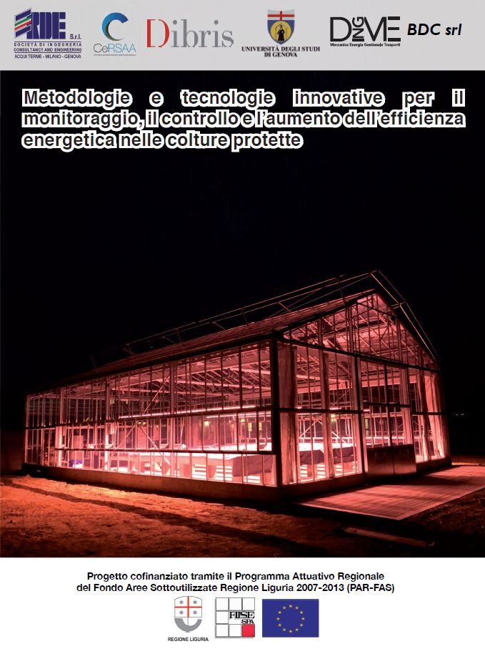

Figure 1. Innovative greenhouse realized at Cersaa (Center for Agricultural Experimentation and Assistance) in Albenga, Liguria Region, Italy. The light in the greenhouse is the result of a low consumption lighting system based on LED technology.

|  |  |
| --- | --- |
|  |  |
| Live_2019_10_07_ore15 | |

Figure 2. Nemo's Garden project, Liguria Region,( Italy.). Courtesy of Ocean Reef group.

|  |  |
| --- | --- |
|  |  |
|  |  |

Figure 3. Greenhouse Module for Space System. Source image courtesy of  Dr. [V. Vrakking](https://room.eu.com/contributors/Vincent-Vrakking), German Aerospace Center (DLR),  Germany

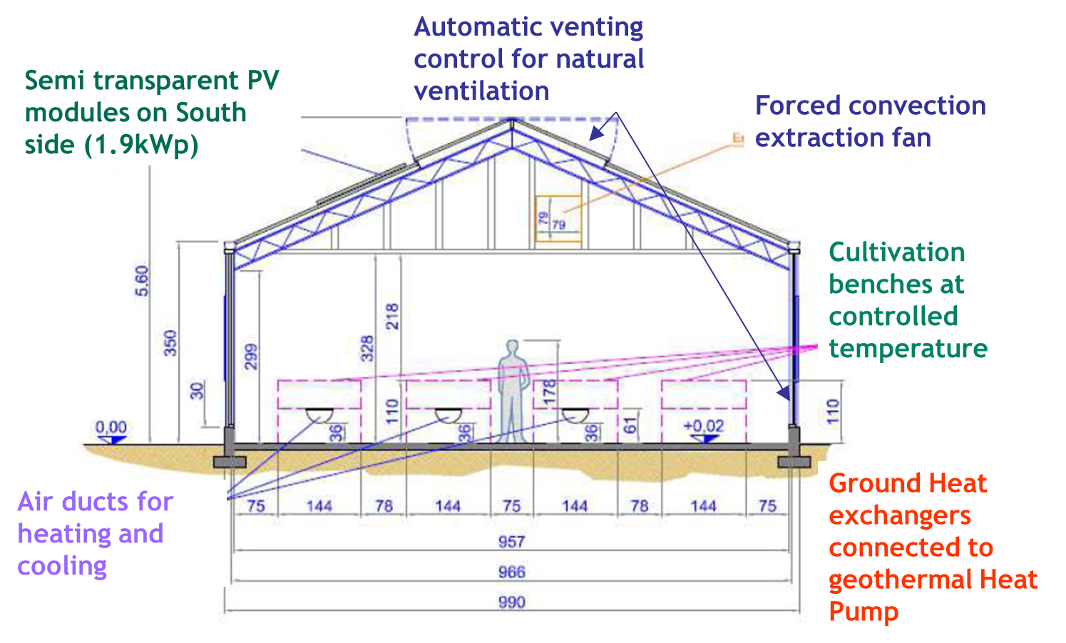

Figure 4. Precision agriculture Lab Greenhouse, Albenga, Italy. Envelope and air conditioning components. Reprinted courtesy by permission of UNIGE

|  |  |
| --- | --- |
|  |  |

Figure 5. The geothermal ground coupled heat pump (GCHP). Geothermal loop manifold and drilling operations. Reprinted courtesy by permission of UNIGE

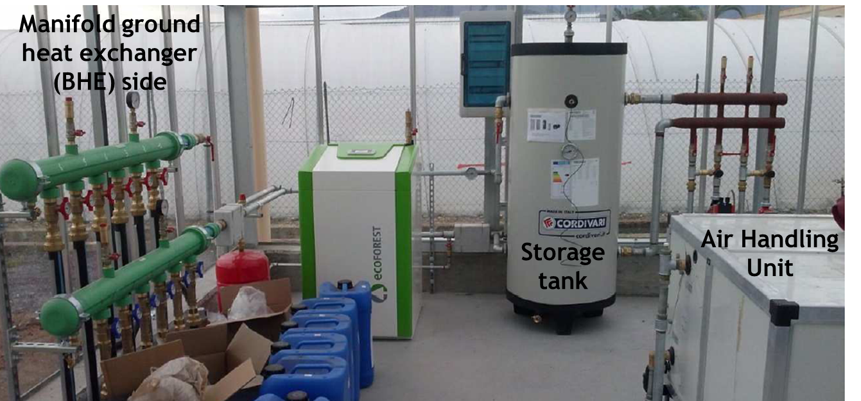

Figure 6. Precision agriculture Lab Greenhouse, Albenga Italy: GCHP based heating system.

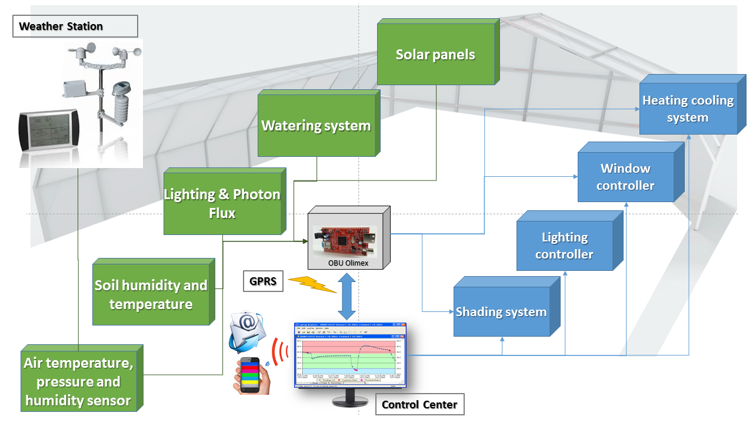

Figure 7. Architecture of the greenhouse monitoring system.

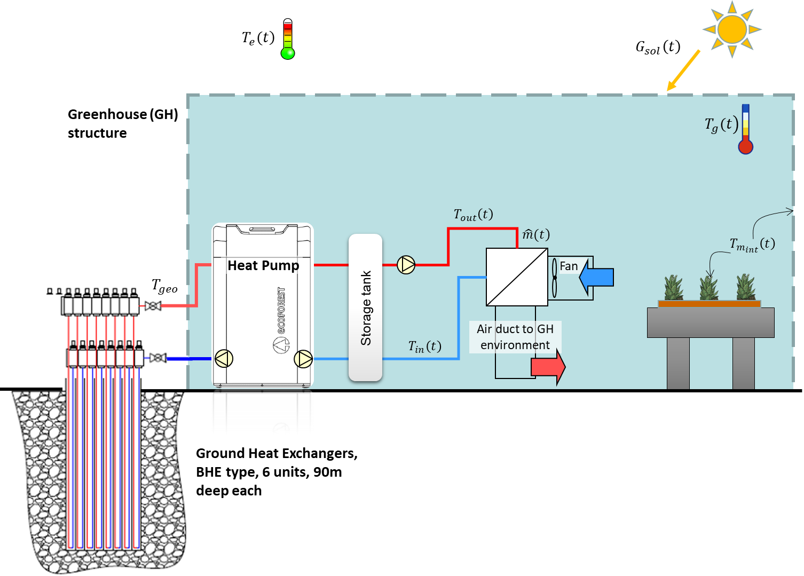

Figure 8. Greenhouse model architecture

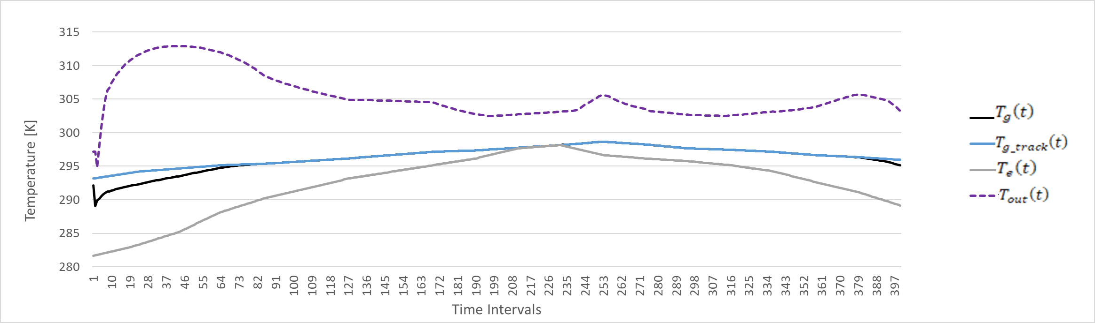

Figure 9. Input and state variables associated to the temperature in MPC approach.

*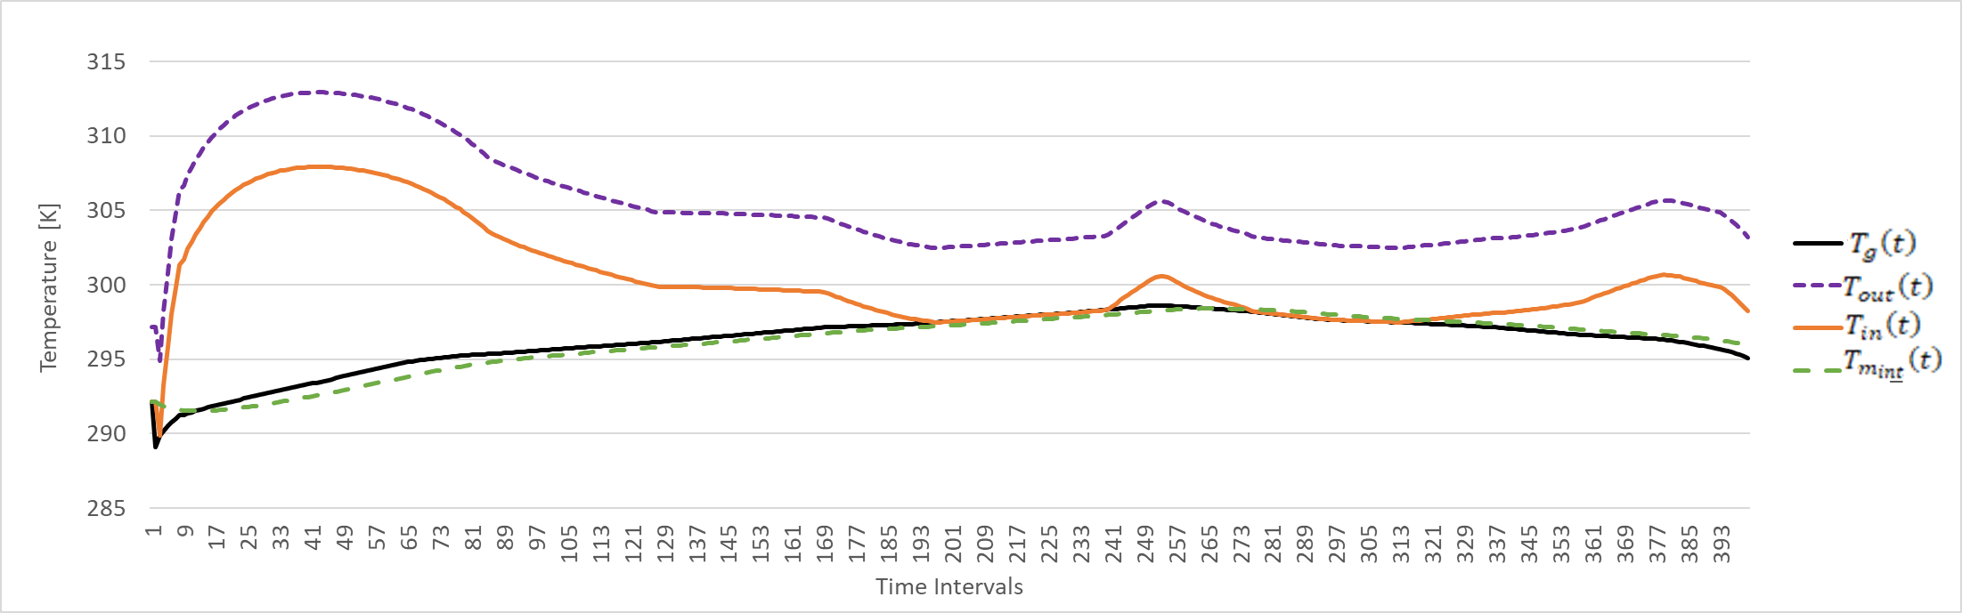*

Figure 10. State and additional variables associated to the temperature in MPC approach.

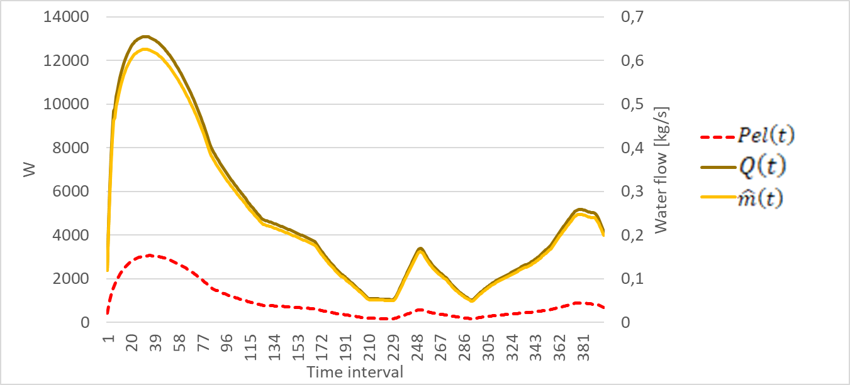

Figure 11. $Pel\left(t\right),$ $Q\left(t\right)$ and control variables values $\hat{m}\left(t\right)$ in MPC approach.

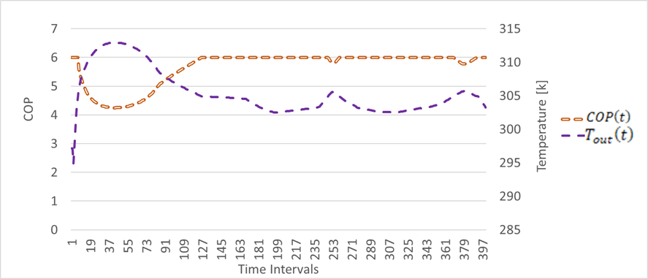

Figure 12. $T_{out}\left(t\right)$ vs $COP\left(t\right)$ values in MPC approach.

**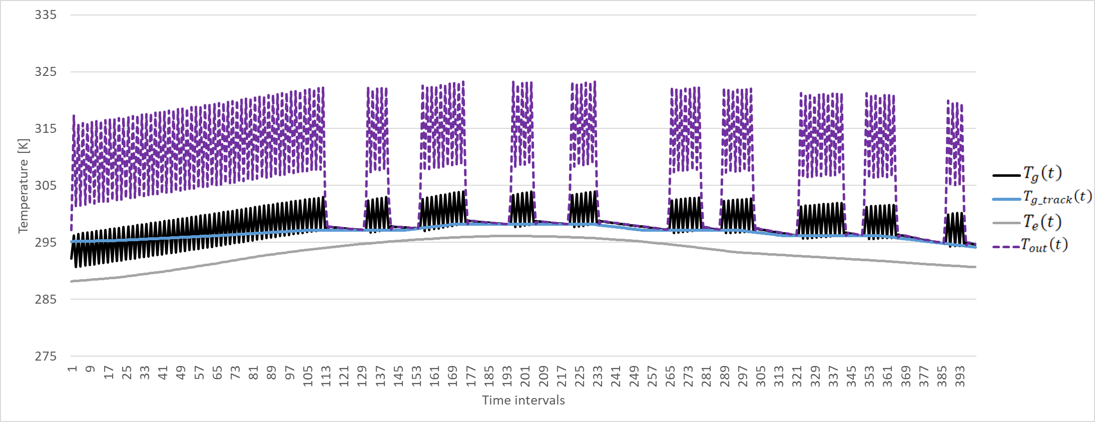**

Figure 13. Input and state associated to the temperature in reactive approach ($crt=1)$.

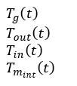**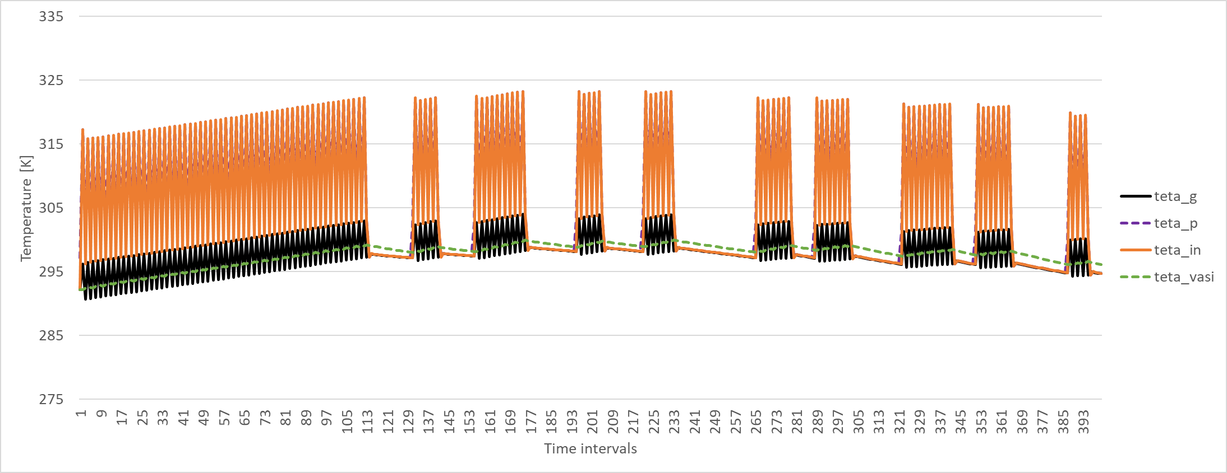**

Figure 14. State and additional variables associated to the temperature in reactive approach $(crt=1)$.

**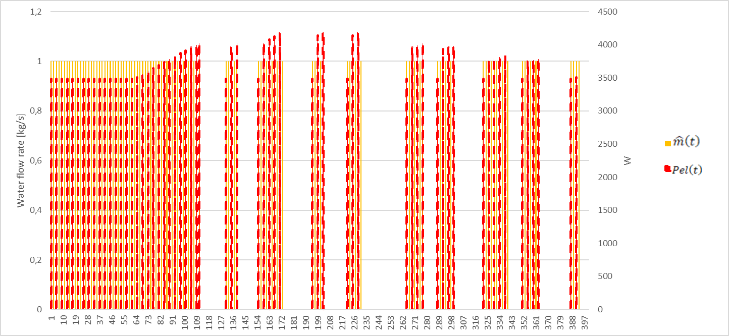**

Figure 15. $Pel\left(t\right)$ and $\hat{m}\left(t\right)$ values in reactive approach.

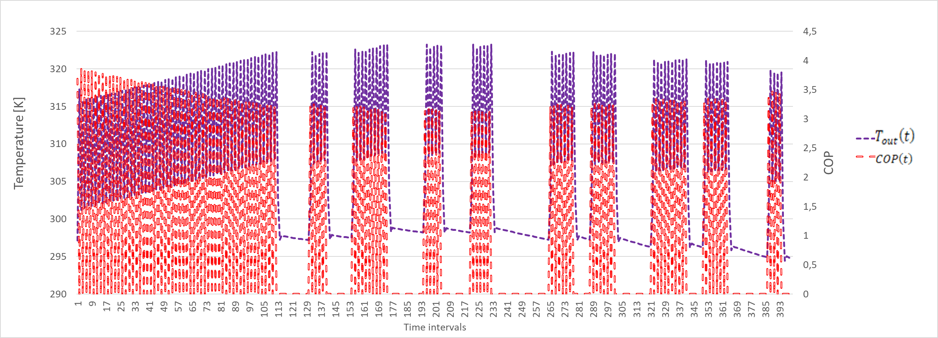

Figure 16. $T_{out}\left(t\right)$ vs $COP\left(t\right)$ values in relay approach.

**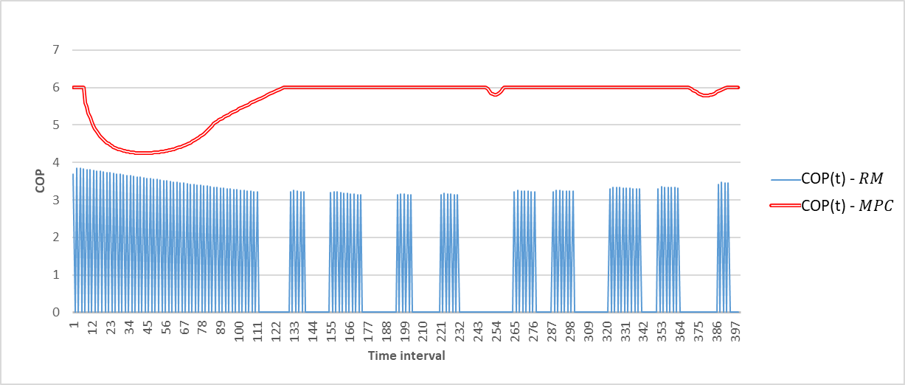**

Figure 17. COP values in MPC vs Reactive Method (RM)

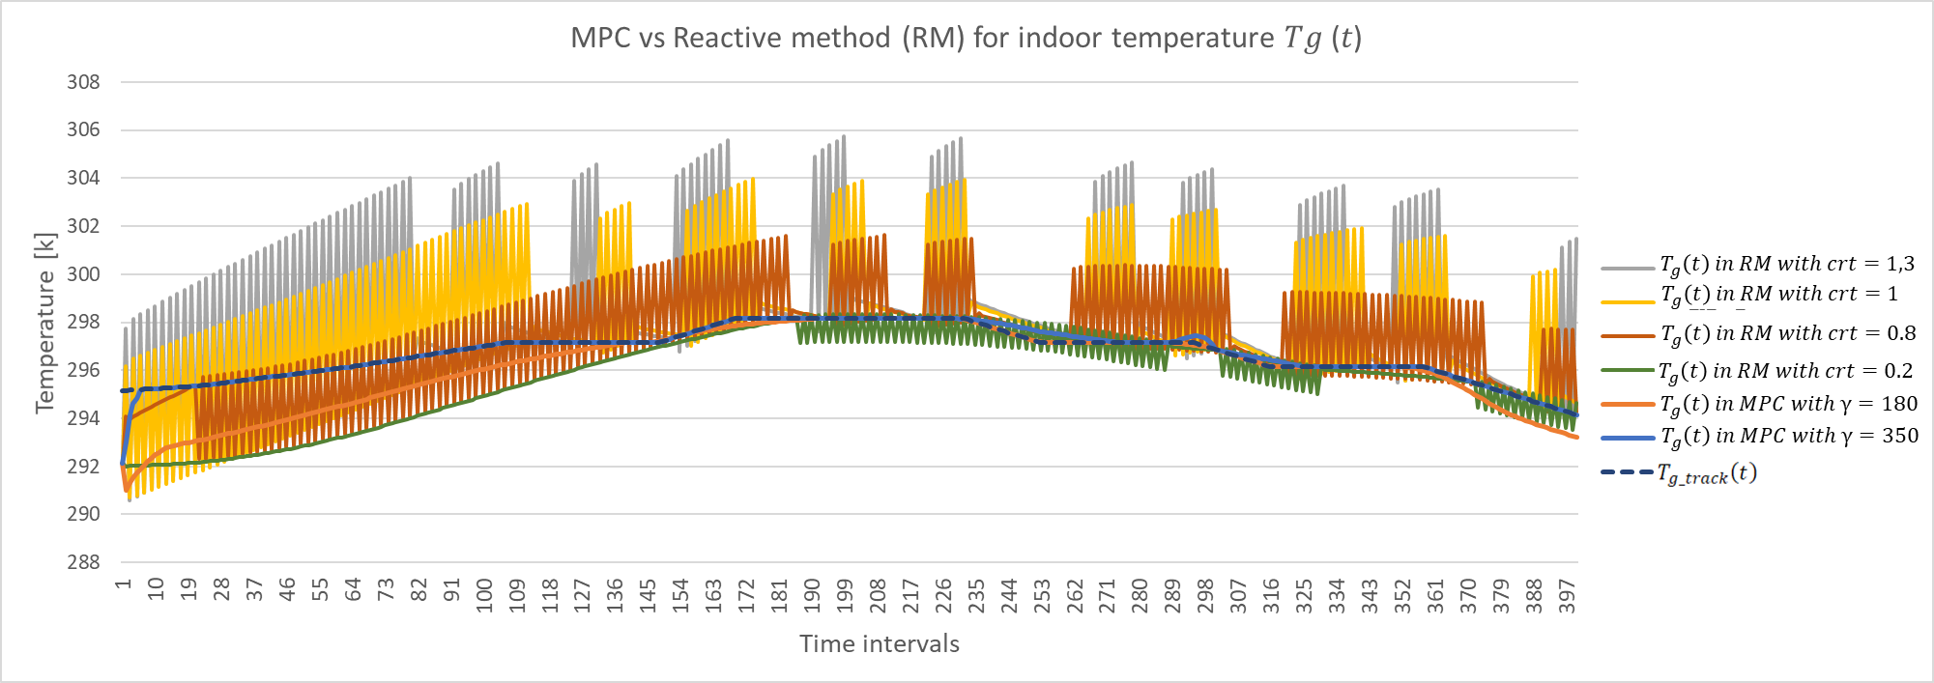

Figure 18. MPC vs Reactive Method performance comparison in respect to the tracking of the indoor temperature.

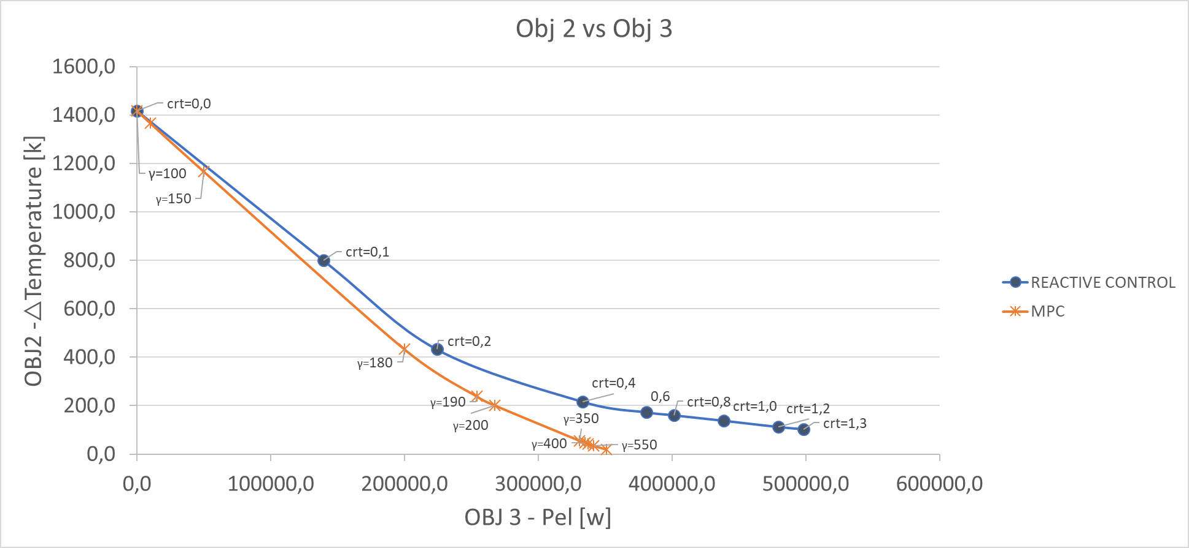

*Figure 19. MPC vs Reactive Method performance comparison.*

Author biography

Chiara Bersani received the Laurea in Computer and System Science Engineering at the University of Genova, Italy and PhD in “Service science applied to transport and logistics systems” from the University of Genoa. She has been co-editor of the recent books “Hydrogen Infrastructure for Energy Applications: Production, Storage, Distribution and Safety” and “Advanced Technologies and Methodologies for Risk Management in the Global Transport of Dangerous Goods”.

Her main research activities are related to energy, transport and logistics systems, with special reference to hazardous material management and inventory routing problems. She collaborated in the national and international projects focusing on the implementation of advanced and innovative technological solutions necessary to optimize renewable energy systems and logistics activities with particular attention to decision making regarding the distribution of goods.

*Corresponding authors: chiara.bersani@unige.it*

Professor Fossa, PhD, is full Professor at Dime Department ([www.dime.unige.it](http://www.dime.unige.it)) of the University of Genova, Italy. He is in charge of MSc classes of Applied Thermodynamics and Heat Transfer, Renewable Energies, Solar and Geothermal Energy. He is the Coordinator of thr MSc course in Energy Engineering ([www.en2.unige.it](http://www.en2.unige.it)) since its constitution, year 2014. Research fields include Geothermal heat pumps, Solar Energy, High Efficiency Greenhouses, Heat Transfer and Fluid Flow Measurements, Thermal Energy System Modelling. He has been visiting professor at the University of the New South Wales, Sydney (2006, 2008, 2010, 2012, 2017), MCI University Innsbruck (2018, 2019, 2020), University of Nottingham, SChEME (2001) and CMS particle detector project at Cern, Geneva (1991, 1992, 1997-2005). Professor Fossa is author of about 150 scientific papers in the field of Thermal Engineering.

Antonella Priarone

Roberto Sacile (M’11) received a Laurea degree in electronic engineering from the University of Genova, Genova, Italy, in 1990 and the Ph.D. degree from Milan Polytechnic, Milan, Italy, in 1994. Post-doc at the French National Institute for Research in Computer Science and Control (INRIA), Sophia Antipolis, France, he is with University of Genova since 2000. His main research interests are related to decision support methodologies and optimal control techniques with specific applications to energy, environmental and transport systems.

Enrico Zero is a PhD student at University of Genoa in Computer Science and System Engineering, he received his master degree in Biostatistics and Statistical Experimental at University of Milano – Bicocca in 2015. He is a research fellow at the University of Genoa from 2015. In his work, he is responsible of statistical analysis about interactions of automotive data and physiological signals during the road transport of dangerous goods.